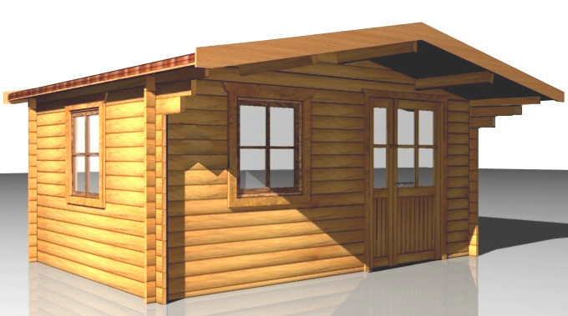

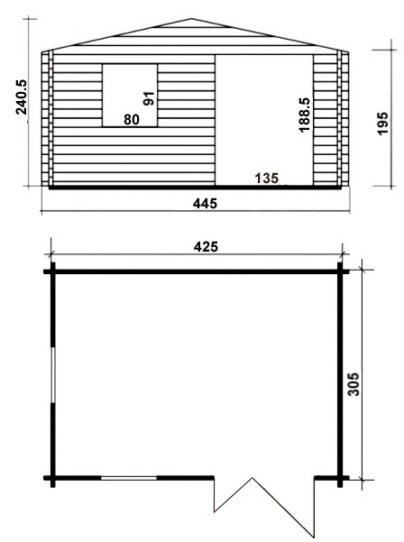
£1,742
Consists of:

Walls: sturdy 45 mm double tongue and groove wall boarding from northern fir.

Flooring: 20 mm tongue and groove floor boards on the impregnated fundament frame. Floor fringes.

Roof: 20 mm tongue and groove roof boards on the roof beams. Overhanging canapy – 100 cm.
Roof coating is not included in the price.

Door: 1 unit 135/185, two-sided.
The doors could be fully glazed, glass on top half or without glass.

Windows: 2 tilt‘n‘turn units 80/88.

